St. Mary’s
Knockbeg College

Anti-Bullying Policy

and

Code of Procedures

Academic Year 2022/23

1. Mission Statement
Our school exists to provide a balanced and holistic education for each of our students. Our aim is to enable and empower students to acquire the self-confidence, academic qualifications, life skills and attitudes for leading satisfying lives which should contribute to the betterment of the Church and society. We regard ourselves as a Christian community where the values of the Gospel find daily expression in our Catholic ethos and all our policies and practices as we nourish a spirituality of compassion, justice, and forgiveness.

2. Policy Rationale
In accordance with the requirements of the Education (Welfare) Act 2000 and the code of behaviour guidelines issued by the NEWB, the Board of Management of St. Mary’s Knockbeg College has adopted the following anti-bullying policy within the framework of the school’s overall code of behaviour. This policy fully complies with the requirements of the Anti-Bullying Procedures for Primary and Post-Primary Schools which was published in September 2013. This anti-bullying policy sets out, in writing, the framework within which the whole school community of St. Mary’s Knockbeg College manages issues relating to bullying and the school’s strategy to prevent bullying behaviour.

This anti-bullying policy has been drawn up to increase the awareness of bullying behaviour in the school community. The Board of Management recognises the very serious nature of bullying and the negative impact that it can have on the lives of pupils. We in St. Mary’s Knockbeg College, believe that all members of the school community have a responsibility to care for each other and provide a supportive and safe environment, free from the fear or reality of being bullied.

This policy is consistent with other policies in St. Mary’s Knockbeg College:
- Admissions Policy
- Code of Behaviour
- Suspension and Exclusion Policy
- Child Protection
- Dignity in the Workplace Policy
- Acceptable Use Policy
- Health and Safety Policy
- RSE and SPHE Policy

3. Goals
The Board of Management recognises the very serious nature of bullying and the negative impact that it can have on the lives of students or staff and is therefore fully committed to the following key principles of best practice in preventing and tackling bullying behaviour.

1. A positive school culture and climate which:
- is welcoming of difference and diversity and is based on inclusivity,
- encourages students and staff to disclose and discuss incidents of bullying behaviour in a non-threatening environment,
- and promotes respectful relationships across the school community.
2. Effective leadership.
3. A school-wide approach.
4. A shared understanding of what bullying is and its impact.
5. Implementation of education and prevention strategies, including awareness raising measures that:
- build empathy, respect and resilience in students,
- and explicitly address the issues of bullying.
6. Effective supervision and monitoring of students.
7. Supports for staff.
8. Consistent recording, investigation and follow up of bullying behaviour (including use of established intervention strategies) and the
9. On-going evaluation of the effectiveness of the anti-bullying policy.

4. Scope of the Policy
The policy addresses bullying behaviour, harassment and sexual harassment and applies to all members of the school community in St. Mary’s Knockbeg College, in accordance with the Employment Equality Acts 1998 and 2004. The nine grounds of discrimination, as outlined under legislation are gender, marital status, family status, age, disability, sexual orientation, race, religion, and membership of the Traveller Community.
The school reserves the right to apply it’s bullying policy in respect of bullying that occurs at a location, activity, function or program that is not school related if, in the opinion of the principal and/or the Board of Management, the alleged bullying has created a hostile environment at school for the victim, has infringed on the rights of the victim at the school and/or has materially or substantially disrupted the education process or the orderly operation of the school.

All members of the school community are subject to this code, particularly the following relationships:
- Student to Student
- Student to any Staff member
- Staff member to Student
- Parent / guardian to Staff member
- Staff member to Parent
- Staff member to Staff member

This policy applies to interactions
- In class.
- Between classes.
- On the school premises.
- On the way to and from school.
- On any school related activity.
- To anything that occurs in the school’s name.
- To any behaviour, that in the view of the Principal, adversely affects the school’s reputation.
5. What is Bullying?
In accordance with the Anti-Bullying Procedures for Primary and Post-Primary Schools (DES, 2013), bullying is defined as, ‘’unwanted negative behaviour, verbal, psychological or physical conducted by an individual or group against another person (or persons) and which is repeated over time’’.
Bullying is typically a repeated action by an individual or a group against others. A once-off incident may be bullying if it leaves the person in ongoing fear and affects their daily well-being. This should not be confused with the good-natured banter that goes on as part of the normal social interchange between students or the normal professional classroom management by teachers.

Isolated or once-off incidents of intentional negative behaviour, including a once off offensive or hurtful text message or other private messaging, do not fall within the definition of bullying and should be dealt with, as appropriate, in accordance with the school’s code of behaviour.
However, in the context of this policy, placing a once-off offensive or hurtful public message, image or statement on a social network site or other public forum where that message, image or statement can be viewed and/or repeated by other people will be regarded as bullying behaviour.

Negative behaviour that does not meet this definition of bullying will be dealt with in accordance with the school’s code of behaviour. The following diagram illustrates the types of bullying behaviour that exist However, each case must be measured in its own right on a case-to-case basis to clarify if it is bullying or an incident under Code of Behaviour rules.
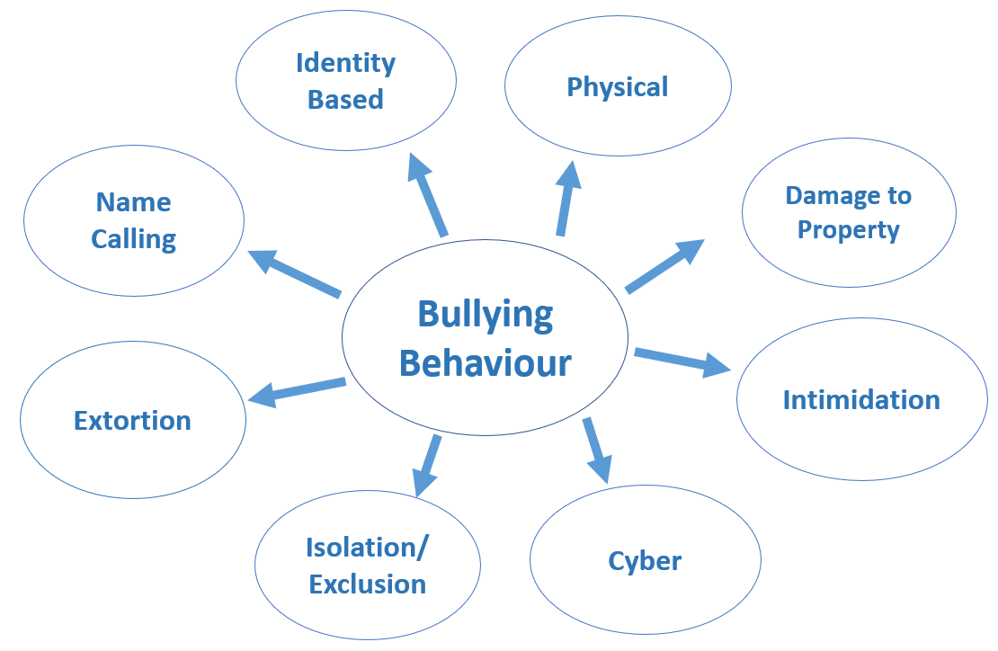
5.2 Examples of Bullying
The following table illustrates some specific examples of each type of bullying. This list is not exhaustive.
Type of Bullying | Example of Behaviour (may be Physical, Verbal or Psychological in nature)
Physical Aggression | - Pushing/shoving/tripping/poking and tripping people up.  - Severe physical assault.  - Sometimes ‘mess fights’ or ‘messing’ fights can be a disguise for physical harassment or inflicting pain.
Intimidation | - Using very aggressive body language.  - Voice being used as a weapon.  - Facial expression which conveys aggression and/or dislike.
Identity Based | - Homophobic or racist comments or behaviour.  - Bullying those with special needs or a disability.  Bullying based on a person’s membership of the travelling community.
Relational Bullying Isolation/Exclusion | - Deliberately isolating/excluding or ignoring a person by some or the entire class group.  - May be accompanied by the writing of insulting remarks about the person in public places/passing around notes or drawings of the person/whispering insults about the person loud enough to be heard.  - When a person’s attempts to socialise and form relationships with peers are repeatedly rejected or undermined.  - Control, such as ‘do this or I won’t be your friend anymore’, which is implied or stated.  - A group ganging up against one person.  - Non- verbal gesturing/ /giving them the ‘silent treatment’.  - Malicious gossip or spreading rumours about a person.
Cyber | - Occurs through text/social network sites/e-mail/instant messaging (IM) apps/gaming sites/chat rooms/other online technologies.  - Being the target of inappropriate or hurtful messages.  - Can occur at any time-day or night.  - Many forms of bulling can be facilitated through cyber bullying.  - Silent telephone/mobile phone call.  - Abusive, harassing or threatening text messages, phone calls, emails, social network comments.  - Recording or circulating incidents, for example a fight and then posting it online  - Sending or uploading photos of any kind without permission.  - The taking and publishing of unauthorised photographic/video footage of any member of the school community.  - Bullying using Snapchat, Instagram, Tik Tok, YouTube or other social network sites, iPhone or smartphones  - Flaming which is defined as posting or sending offensive messages over the Internet. These messages, called flames, may be posted within online discussion forums or newsgroups, or sent via e-mail or instant messaging programs.  - Happy slapping for example physically attacking and often verbally abusing a person and photographing or filming the attack with the recording sometimes being sent to others to further humiliate the victim.
Name Calling | - Persistent name calling directed at the same person which hurts/insults/humiliates usually regarding physical appearance.  - Accent or distinctive voice characteristics.  - Academic ability - weak achievers or high achievers.
Damage to property | - Personal property-clothing/mobile or other devices.  - School books/other learning materials/lockers/bicycles.  - Contents of school bags/pencil cases scattered on floor.  - Items of personal property may be defaced/broken/stolen/hidden.
Extortion | - Demands for money which are often accompanied by threats or actual damage in the case of non-delivery.  - A student might be forced into theft of property for delivery to the student engaged in bullying.

5.3 Signs and Indicators of Bullying
Students who are being bullied may develop feelings of insecurity and extreme anxiety and thus become more vulnerable. Self-confidence may be damaged with the consequent lowering of self- esteem. While they may not talk about what is happening to them their suffering is indicated through changes in mood and behaviour.
Bullying may have a negative impact on personal well-being. It is important to recognise and respond to changes in behaviour as early as possible.

6. Identifying actions to prevent bullying behaviour
The education and prevention strategies that will be used by the school are as follows:
Publishing and Publicising an Anti-Bullying Policy | - Excerpts from the Anti-Bullying Policy will be visible throughout the school in corridors and classrooms.  - The Anti-bullying policy will be published on the school website www.knockbegcollege.ie, in the school Code of Behaviour and in first year induction booklets for students and parents.  - The Anti-Bullying Policy will be promoted at various gatherings including parents’ nights, first year enrolment, open nights and year group assemblies.  - We document the specific education and prevention strategies that the school will implement to address bullying with effective practice including prevention and awareness raising measures across all aspects of bullying and involves strategies to engage pupils in addressing problems when they arise.
Supervision and Monitoring | - Bullying “black spots” within the school will be identified and monitored during break times.  - CCTV is in operation, and we ensure that there is adequate supervision before, during and after school.  - Staff will be vigilant in following the procedures as outlined in this policy.  - Social networking sites are blocked by school firewall. However, students who can access sites on their own mobile network are required to do so responsibly and not to infringe upon the Anti-Bullying Policy. This Policy operates in conjunction with the school’s Acceptable Use Policy.
Extra-Curricular | - We provide students with opportunities to develop a positive sense of self-worth through extra-curricular programmes because we recognise that self-esteem is a major factor in determining behaviour.  - We promote co-operation and group enterprise through teamwork. Sports and other clubs and societies as well as through practical subjects, provide excellent opportunities for channelling and learning how to control aggression and work effectively with others.
Inclusive | - Our approach to tackling and preventing bullying takes particular account of the needs of pupils with disabilities or with AEN and joins up with other relevant school policies and supports.
Student Involvement | - In their role of school leaders, Prefects and Meitheal Leaders, shall observe student behaviour and report incidents to the supervising teacher / Class Teacher / Management.  - Meitheal Leaders support new students settle into the school through the Meitheal Programme and act as a support guide for students.  - The Wellbeing Team along with the Student Council in highlighting the Anti-Bullying Policy and in organising activities that raise awareness and prioritise anti-bullying interventions during anti-bullying week?  - The Wellbeing Co-ordinator will meet new students and international students to our school following their arrival to help them settle into our school community
Inclusion in the Curriculum | - The FUSE Anti-Bullying Programme in addition to lesson resource plans from the PDST, will be implemented into the curriculum with anti-bullying topics being taught in SPHE, CSPE and Religion classes.  - Computer classes will explore rights and responsibilities when online, personal safety and strategies to recognise and avoid online bullying.  - Guidance and Counselling Service: A survey on Primary/Secondary Transfer will include questions on how well they are settling into school.  - The Relationship and Sexuality Education (RSE) programme provides opportunities to explore and discuss areas such as human sexuality and relationships, which has particular relevance to identity-based bullying. We recognise that continuous professional development for teachers is required in this area of work.  - We work to raise the awareness of bullying so that all members of the school community understand what bullying is and how the school deals with bullying behaviour. We organise anti-bullying talks and training during Anti-Bullying Week and celebrate friendship and positivity within the school community. The subject is discussed with each year group at the beginning of the year and is spoken about at assemblies throughout the year.
Developing positive school culture | - There is space within the teaching of all subjects to foster an attitude of respect for all: to promote the value of diversity; to address prejudice and stereotyping and to highlight the unacceptability of bullying behaviour. For example, in English, we use literature to stimulate discussion and in Geography and History we use references to colonisation, exploitation and dictatorships to illustrate the negative aspect of power.  - In addition, an area of focus in the SSE 2016 – 2022 cycle is on developing positive relationships within the school community in the online space. This work will complement the many other positive anti-bullying strategies that take place across the school community and will measure success in this area over a three year-period.
Involving parents/guardian and the wider community | - Awareness of the Anti-Bullying Policy will be raised on parents’ nights e.g. First Year enrolment and open nights and in first year induction booklets.  - A text will be sent to Parents/Guardians when questionnaires are being distributed to the students. This will give them an opportunity to discuss their son/daughter’s responses with them.  - An open-door culture exists within the school and will be built on to ensure that parents and guardians and those in the wider school community such as bus drivers feel they can discuss issues of concern regarding bulling with school management.

7. The Steps to be taken when dealing with bullying incidents
The Board of Management of St. Mary’s Knockbeg College has ensured that the school has clear procedures for the formal noting and reporting of bullying behaviour which are documented in this anti-bullying policy. All records must be maintained in accordance with relevant data protection legislation.

While all reports, including anonymous reports of bullying must be investigated and dealt with by the relevant teacher, the relevant teacher will use his/her professional judgement in relation to the records to be kept of these reports, the actions taken and any discussions with those involved regarding same. If it is established by the relevant teacher that bullying has occurred, the relevant teacher must keep appropriate written records which will assist his/her efforts to resolve the issues and restore as far as is practicable, the relationships of the parties involved.

The relevant teacher must use the ‘form for recording bullying behaviour’ to record the bullying behaviour in the following circumstances: in cases where he/she considers that the bullying behaviour has not been adequately and appropriately addressed within 20 school days after he/she has determined that bullying behaviour occurred; and where the school has decided that in certain circumstances bullying behaviour must be recorded and reported immediately to the Principal or Deputy Principal.

7.1 Reporting procedures for Students
In the case where a student(s) is being bullied he should be able to approach the following people
Who to tell?
- Parents
- Any staff member with whom the student feels comfortable
- Meitheal leader
- Friends who will speak on your behalf
- Class Teacher or Year Head
- Guidance Counsellor
- Deputy Principal
- Principal
How to tell?
- Get a parent / guardian to make a phone call to the school or to a trusted teacher in the school.
- Get a parent / guardian or friend to tell on your behalf.
- Bystanders can inform an appropriate person.
- Direct approach to your teacher at an appropriate time, e.g. after class, hand note up with homework.
- Write on the confidential questionnaire/ sociogram given to your class or year group

It is important to note that records of all incidents of bullying and action taken to resolve them will be kept.

7.1 Recording of Incidents of Bullying
Students, parents, teachers, and non-teaching staff such as, administrative, special needs assistants, caretakers, cleaners, sport’s coaches, those taking extra circular activities and those driving school buses.
members of the wider community will be encouraged to report any incidents of bullying behaviour witnessed by them, or mentioned to them, to either a teacher or the Principal or Deputy Principal.

The school’s procedures for investigation, follow-up and recording of bullying behaviour and the established intervention strategies used by the school for dealing with cases of bullying behaviour are as follows:

- Once a report is made to a staff member, he/she will investigate, determine, and document as appropriate: (See flowchart and Appendix 1; Initial Investigation Form.)
- The completed Initial Investigation Form is passed onto the Class Teacher and Year Head who will complete Appendix 2, the Bullying Incident Report Form.
- Completed forms will be stored in a folder online for viewing by the Senior Management Team (these files are kept separate from the students’ main school file).
- Files are to be kept for five years after the student leaves the school (these files may be accessed by students/parents in the future).
- Staff will be informed of necessary developments in bullying incidents by the Care Team. This will take place during staff briefings and/or by distributing relevant details (Password Protected) via office 365. They will be asked to monitor and specific incidents and to pass on these observations to a member of the Care Team if they have concerns.
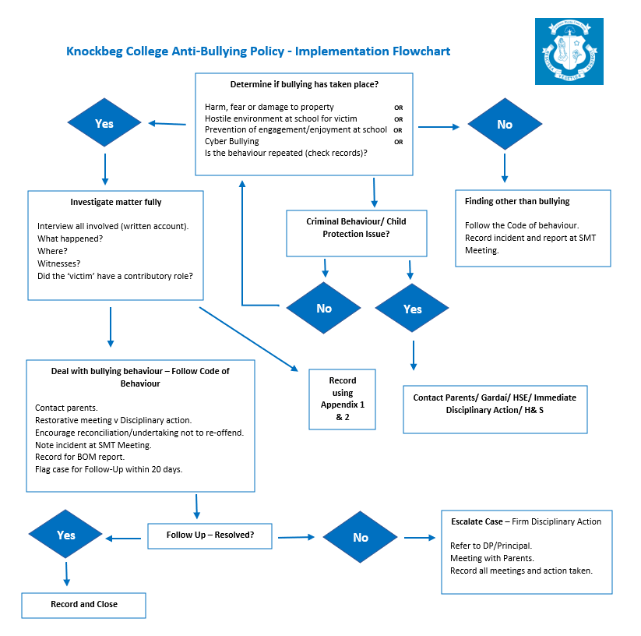

7.1.1 Time Frame and Response
In cases where the relevant teacher considers that the bullying behaviour has not been adequately and appropriately addressed within 20 school days, it is the responsibility of the teacher to discuss the matter with the Year Head.
In determining whether a bullying case has been adequately and appropriately addressed the relevant teacher must, as part of his/her professional judgement, take the following factors into account:
- If the bullying behaviour has ceased.
- If any issues between the parties have been resolved as far as is practicable.
- If the relationships between the parties have been restored as far as is practicable.
- Any feedback received from the parties involved, their parents or the school Principal or Deputy Principal.

8. Supports for those affected by bullying
A programme of support for pupils who have been bullied is in place in Knockbeg College. Such pupils may need counselling and/or opportunities to participate in activities designed to raise their self-esteem, to develop their friendship and social skills and thereby build resilience whenever this is needed. We adopt a method of shared concern. We use restorative practice, mediation or reconciliation where appropriate. We maintain open communications between school, parents and outside agencies. We work together to resolve the situation and protect the victim.
A programme of support for those pupils involved in bullying behaviour is also part of the school’s intervention process. Pupils involved in bullying behaviour need assistance on an ongoing basis. For those with low self-esteem, opportunities are developed to increase feelings of self-worth. Pupils who engage in bullying behaviour may need counselling to help them learn other ways of meeting their needs without violating the rights of others

9. Referral of serious cases to the HSE
In relation to bullying in schools, Children First National Guidance for the Protection and Welfare of Children 2011 (Children First) and the Child Protection Procedures for Primary and Post-Primary Schools provide that in situations where “the incident is serious and where the behaviour is regarded as potentially abusive, the school must consult the HSE Children and Family Social Services with a view to drawing up an appropriate response, such as a management plan”.
Serious instances of bullying behaviour are, in accordance with the Children First and the Child Protection Procedures for Primary and Post-Primary Schools, referred to the HSE Children and Family Services and/or Gardaí as appropriate. The Child Protection Procedures for Primary and Post-Primary Schools also that where school personnel have concerns about a child but are not sure whether to report the matter to the HSE, the Designated Liaison Person must seek advice from the HSE Children and Family Services.
10. Appeal
Where a parent/guardian or a student who is more than 18 years old is not satisfied that the school has dealt with a bullying case in accordance with the Anti-Bullying Procedures for Primary and Post-Primary Schools, they will be advised of their right to make an appeal to St. Mary’s Knockbeg College’s Board of Management. Such appeals shall be submitted, in writing setting out the grounds for the appeal, to the Chairperson of the Board within 15 school days of the parent/guardian informing the Principal that they form the opinion that St. Mary’s Knockbeg College has not dealt with the bullying case in accordance with the Anti-Bullying Procedures for Primary and Post-Primary Schools. Where a parent/guardian, having exercised their appeal to the Board of Management and is still not satisfied they will be advised of their right to make a complaint to the Ombudsman for Children.

11. Roles and Responsibilities
11.1 Senior Management
The Principal, supported by Deputy Principal and Year Heads, shall have overall control and responsibility for the implementation of the policy including its publicity at staff meetings, parent / guardian teacher meetings and assemblies. They will be responsible for its ratification and the summary reports to the Board of Management at least once in every school term.
The Principal / Deputy Principal must provide a report to the Board of Management setting out:
- The overall number of bullying cases reported (by means of the bullying recording template at Appendix 2) since the previous report to the Board and
- Confirmation that all cases referred to above have been or are being dealt with in accordance with the school’s Anti-bullying policy and the Anti- Bullying Procedures for Primary and Post-Primary schools. The minutes of the Board of Management meeting must record the above but in doing so must not include any identifying details of the pupils involved.
The Year Head shall support the Principal and Deputy Principal in implementing the Anti bullying policy. Where necessary they may contact parents and the relevant authorities. The Year Head will be responsible for collating all information regarding all incidents and meetings.

11.2 Teaching Staff
Subject Teachers must report all incidents of bullying behaviour to the relevant Year Head. The teacher must document all incidents of bullying behaviour within their classroom or outside of it e.g. corridors etc. This written report shall be submitted to the Year Head. Teachers will promote the anti-bullying policy. All teachers must be constantly vigilant of any bullying behaviour with the children under their care.
The Guidance Counsellor shall be responsible for reporting incidents and arranging counselling for the referred student/s.
Class Teachers in conjunction with the relevant Year Head, shall act as a support to the victim and bully.
11.3 Students
Students have the responsibility of complying with the anti-bullying policy. The student will also have the responsibility of reporting incidents of bullying that they are subject to or have witnessed. The student will also have the responsibility to participate actively in anti-bullying initiatives.
11.4 Parent/Guardians
Parents/Guardians have responsibility to uphold the recommendations within the policy and to accept the sanctions held within it. Where incidents of bullying are occurring to their child, they will have the responsibility of reporting this to the relevant Year Head or staff member.
11.5 Board of Management
The Board of Management is responsible for the implantation of the anti-bullying policy. It confirms that appropriate supervision and monitoring policies and practices are in place to both prevent and deal with bullying behaviour and to facilitate early intervention where possible.
The Board of Management confirms that the school will, in accordance with its obligations under equality legislation, take all such steps that are reasonably practicable to prevent the sexual harassment of pupils or staff or the harassment of pupils or staff on any of the nine grounds specified i.e. gender including transgender, civil status, family status, sexual orientation, religion, age, disability, race and membership of the Traveller community.
This policy has been made available to school personnel, published on the school website and provided to the Parents’ Association and Student Council. A copy of this policy will be made available to the Department and to the Trustee if requested.
This policy and its implementation will be reviewed by the Board of Management once in every school year. Written notification that the review has been completed will be made available to school personnel, published on the school website and provided to the Parents’ Association and Student Council. A record of the review and its outcome will be made available, if requested, to the Trustee and the Department.

This policy was adopted by the St. Mary’ Knockbeg College Board of Management on 12-01-2022

Signed: Michael Regan
Date: 25-01-2024
Chairperson, Board of Management

Signed : 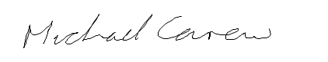
Date: 25-01-2024
Principal
Date of next review January 2024
APPENDIX 1: ST. MARY’S KNOCKBEG COLLEGE

ANTI-BULLYING POLICY – INITIAL INVESTIGATION FORM

Name(s) of Student Student(s):

Details of Incident:
Only details which are pertinent to the incident/case are to be recorded.

Signed by teacher recording the incident:

_______________________________ Date:_____________

Is this deemed a behaviour or bullying incident? Circle accordingly Yes No

Signed by Class Teacher/Year Head
___________________________ Date:_______________

Recommending use of ‘Report of Bullying Behaviour’. Circle accordingly Yes No
APPENDIX 2: ST. MARY’S KNOCKBEG COLLEGE

REPORT OF BULLYING BEHAVIOUR

1. Name of pupil allegedly being bullied and class group

Name _________________________________________ Class__________________

2. Name(s) and class(es) of students(s) engaged in alleged bullying behaviour

3. Source of bullying concern/report (tick relevant box(es))* |  | 4. Location of incidents (tick relevant box(es))*
Pupil Concerned |  | Locker Area
Other Pupil |  | Toilets
Parent |  | Classroom
Teacher |  | Corridor
Prefect/Meitheal Leader |  | Ref/Colonnade
Other |  | Playing fields/touch
 |  | School Bus
 |  | Other

5. Name of person(s) (Initials/Vs Ware ID) who reported the bullying concern

6. Is CCTV footage available in the area where it is reported that bullying took place? YES / NO
If Yes was the CCTV footage reviewed and who reviewed this footage, date & time.
Date/Time: _______________________ Personnel:_________________________

7. Type of Bullying Behaviour (tick relevant box(es)) *
Physical |  | Cyber-Bullying
Damage to Property |  | Intimidation
Isolation/Exclusion |  | Malicious Gossip
Extortion |  | Identity Based
Name calling |  | Other

If other, specify: _____________________________________________________________________

8. Where behaviour is regarded as identity-based bullying, indicate the relevant category:
Homophobic | Disability/SEN related | Racist | Membership of Traveller community | Other (specify)

9. Brief description of bullying behaviour and impact:
10. Details of Action to be taken:

Signed: ______________________________________ Relevant Teacher
Date: _____________________

Was it resolved within 20 days? Yes No

If Yes:
Signed: ______________________________________ Relevant Teacher
Date: _____________________

If No:
Date submitted to Principal / Deputy Principal: ________________________

APPENDIX 3: ST. MARY’S KNOCKBEG COLLEGE

CHECKLIST FOR ANNUAL REVIEW OF THE ANTI-BULLYING POLICY AND IT’S IMPLEMENTATION

The Board of Management must undertake an annual review of the school’s anti-bullying policy and its implementation. The following checklist must be used for this purpose. The checklist is an aid to conducting this review and is not intended as an exhaustive list. In order to complete the checklist, an examination and review involving both quantitative and qualitative analysis, as appropriate across the various elements of the implementation of the school’s anti-bullying policy will be required.
Yes /No
Has the Board formally adopted an anti-bullying policy that fully complies with the
requirements of the Anti-Bullying Procedures for Primary and Post-Primary Schools?
Has the Board published the policy on the school website and provided a copy to the Parents’ Association?
Has the Board ensured that the policy has been made available to school staff (including new staff)?
Is the Board satisfied that school staff are sufficiently familiar with the policy and procedures to enable them to effectively and consistently apply the policy and procedures in their day-to-day work?
Has the Board ensured that the policy has been adequately communicated to all students?
Has the policy documented the prevention and education strategies that the school applies?
Have all of the prevention and education strategies been implemented?
Has the effectiveness of the prevention and education strategies that have been implemented been examined?
Is the Board satisfied that all teachers are recording and dealing with incidents in accordance with the policy?
Has the Board received and recorded minutes of the periodic summary reports of the Principal?
Has the Board discussed how well the school is handling all reports of bullying including those addressed at an early stage and not therefore included in the Principal’s periodic report to the Board?
Has the Board received any complaints from parents/guardians regarding the school’s handling of bullying incidents?
Have any parents withdrawn their child from the school citing dissatisfaction with the school’s handling of a bullying situation?
Have any Ombudsman for Children investigations into the school’s handling of a bullying case been initiated or completed?
Has the data available from cases reported to the Principal (by the bullying recording template) been analysed to identify any issues, trends or patterns in bullying behaviour?
Has the Board identified any aspects of the school’s policy and/or its implementation that require further improvement?
Has the Board identified any aspects of the school’s policy and/or it has the Board put in place an action plan to address any areas for improvement?

Signed: ______________________________________
Date: ______________________________________
Chairperson, Board of Management

Signed : ______________________________________
Date: ______________________________________
Secretary, Board of Management

