Percent for Art Commission
St. Mary’s Knockbeg College, Knockbeg, Carlow

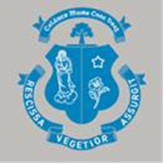

Commision 1: Original stained-glass art to be fitted in existing window opening of college chapel

Commision 2: Decorative screen to sanctuary within college chapel

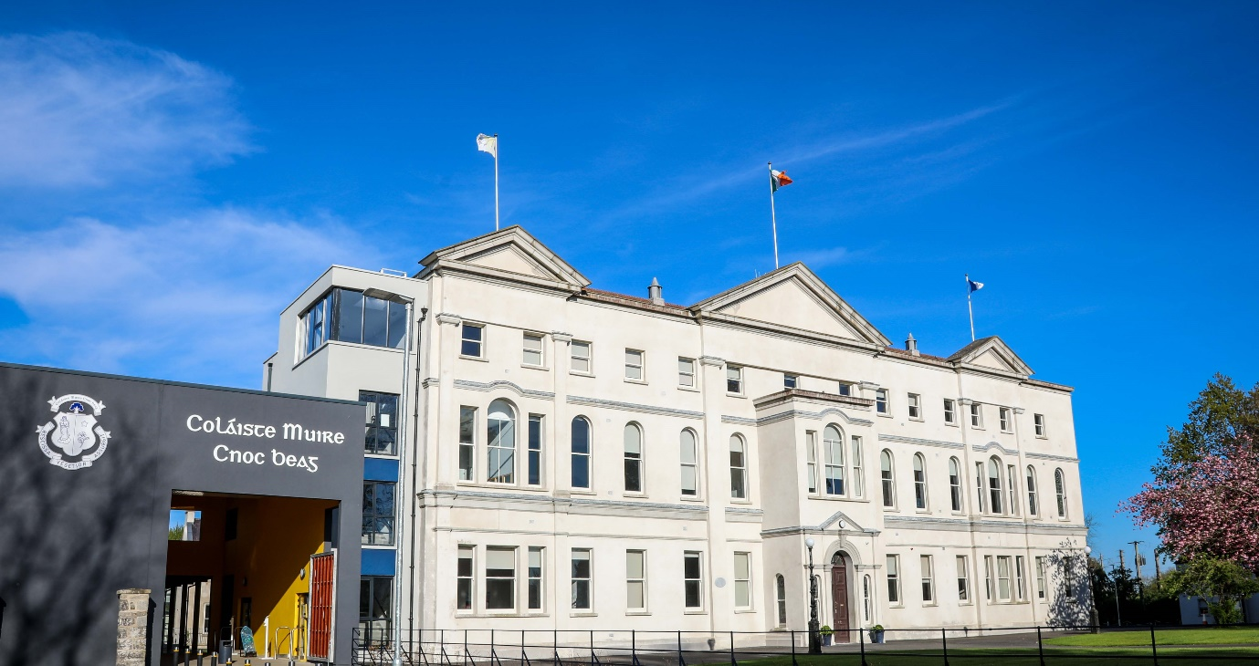

STAGE 1: JUNE 2021

Applicants are requested to read the full content of this document carefully as it contains important information pertaining to all stages of the commission.
INTRODUCTION:
Knockbeg College is an all-boys, non-fee-paying, voluntary Catholic secondary school owned by the Diocese of Kildare and Leighlin and approved by the Dept. of Education and Skills.
Located in a spacious, open, rural setting, the school traces its origins to the late-eighteenth century, when a lay school for boys was established in conjunction with the seminary at St. Patrick’s College in Carlow Town. In 1847, it was decided that the younger pupils in the school should move to the Knockbeg House, a country house located on the banks of the River Barrow about two miles from the centre of Carlow, which had been purchased by the Diocese of Kildare & Leighlin. The initial enrolment of about 40 pupils rapidly grew as all the lay pupils from Carlow College, St. Patrick's transferred out. In 1898, the school became the official junior seminary for the diocese. Although the school no longer functions as a seminary, it retains a strong Christian ethos and the continued objective of offering a holistic Catholic education to its pupils. Knockbeg College has a caring environment and a strong track record in providing for the spiritual, educational, welfare and physical needs of the students.

Knockbeg College operated as a boarding school for many years, with numbers peaking at 160. The number of pupils attending the school increased significantly in the 1980's when day-pupils were enrolled. The boarding function of the school was gradually phased out during the early-2000’s. The school now operates on the basis that all our students remain on campus throughout the school day, with options for hot food service during the day and evening study until 8.00pm Monday to Thursday and 5.30 on Friday. At present, enrolments are increasing and there are approximately 400 pupils in the school.

In 2012, the Department of Education appointed a design team to undertake a comprehensive programme of refurbishment and extension of the facilities at Knockbeg College. The works involved the conservation and upgrading of four protected structures on the site – the mid-eighteenth century Knockbeg House; a three-storey extension to its south; the 1901 Front Range, separated from the early buildings by a landscaped quadrangle; and the 1964 St. Joseph’s Wing, a notable early example of the work of Sam Stephenson – together with the introduction of a number of new buildings, which tie the campus together and create a strong focal point around the central quadrangle. The project was completed in late-2019 and the Board of Management now wish to commission two bespoke pieces of artwork under the Percent for Art scheme.

BRIEF – TWO SEPARATE PIECES OF ART WITHIN THE COLLEGE CHAPEL:
The College Chapel, which is located within the Front Range, has been selected as an appropriate location for the two pieces of art. Whereas the central quadrangle provides a physical and organisational hub, the chapel is the spiritual core of Knockbeg College and holds a special place in the hearts and minds of the staff and pupils, past and present. This large first floor space has been in continuous use as a chapel since the construction of the Front Range. This spacious room has tall sash windows on three sides, which provide plentiful light and offer views of the leafy tree canopies that surround the school. Prior to the recent project, the chapel had a traditional layout, with fixed pews on both sides of a central aisle, facing a raised sanctuary at its southern end. The marble fittings within the sanctuary included surviving components from its original construction in 1901, which had been modified in response to liturgical changes following the Second Vatican Council. As part of the recent works, the marble altar and tabernacle were reassembled as a single component and restored to their original location within the projecting apse to the south. The tabernacle will contain the consecrated Eucharist, with the space in front to be screened from the main body of the chapel to facilitate private reflection and prayer. The remainder of the chapel will operate as a flexible space with loose seating to suit a variety of layouts, with a new moveable altar, ambo and chair, to be located centrally on the east external wall for the celebration of mass.

The Board of Management intends to commission two separate pieces of art to be installed within the chapel as follows:

Commision 1: Stained glass window on east wall of chapel
The proposed stained-glass window will be installed within the existing arched window opening on the east external wall of the chapel. This window opening is currently fitted with a traditional timber sash window with clear glass, which is to be removed. This new window will act as a focal point and backdrop to the moveable altar.

The window is envisaged as a high-quality new piece of ecclesiastical artwork within the refurbished chapel. The primary theme of the stained-glass window is ‘Jesus teaching the young’. A secondary theme is the supportive role of the Virgin Mary in the lives of the young. It is open to artists to focus exclusively on the primary theme or to combine the two themes into a single coherent piece of art. It is open to artists to propose a figurative or abstract interpretation of the theme(s).

This commission will involve the design, creation and installation of the finished piece of stained-glass. While the Stage 1 submissions will primarily be assessed on the artistic response to the brief, artists will need to demonstrate that they have the technical ability to construct and install the completed stained glass. Artists who have not previously worked in stained-glass may wish to collaborate with a stained-glass studio to demonstrate the required technical competence to deliver this commission.

Note:
It is open to artists to put forward proposals that include the flanking square-headed sash window together with the central round-arched window, subject to demonstrating that the complete work is achievable within the budget.

Commision 2: Decorative screen to sanctuary within college chapel
This installation will act as a dividing screen between the main body of the chapel and the south apse, which contains the tabernacle. The raised platform of the apse is intended to provide a quiet space for prayer and reflection facing the marble tabernacle. The screen should provide a tangible separation between the two parts of the chapel, while maintaining a visual connection between the two spaces. The screen must be of robust construction and structurally self-supporting. While this screen was initially envisaged as being of high-quality timber by the project architects, it is open to artists to consider the use of alterative materials such as bronze or glass in their proposal.

The screen is envisaged as a bespoke piece that reflects the sacred importance of the tabernacle and the Eucharist within the chapel, however the screen is not required to incorporate religious motifs. The design should respond to the architectural character of the chapel and to the unique rural setting of Knockbeg College, which can be viewed from the windows of the chapel. It is open to artists to explore designs that are strongly geometric, entirely abstract, or are inspired by nature.

This commission will involve the design, creation and installation of the finished decorative screen. While the Stage 1 submissions will primarily be assessed on the artistic response to the brief, artists will need to demonstrate that they have the technical ability to construct and install the completed screen. Artists who have not previously worked on comparable pieces may wish to collaborate with a specialist craftsperson to demonstrate the required technical competence to deliver this commission.

THE COMMISSIONING PROCESS:
Separate parallel selection competitions will be held for Commision 1 and Commision 2. The selection process for each commission will comprise a Two Stage Open Competition and is open to all interested professional artists at any stage of their career or with any level of experience. Selection will be based on the information supplied, establishing the competence of the artists to carry out this commission. Given the specialist nature of the two briefs, a combination of artistic talents (craft, product design etc.) can be included in submissions.

Stage 1
Artists are invited to express their interest in being considered for one or both of the installations at the first stage of this commission. Separate application forms have been prepared for each commission. Artists should complete the relevant application form, which should be accompanied by a CV, images, details of recent relevant works, past projects, as well as a brief outline/sketch of what they would envisage for this commission based on their knowledge of the school, its location, its ethos, and its characteristic values. The closing date for receipt of Stage 1 completed application form for the relevant commission, together with supporting documentation and material, is 4pm on Friday 30th July 2021. Artists who wish to be considered for both commissions should separately fill in both application forms. Applications may be submitted by email or post – (see Application Form for more details).

Stage 2
From the completed Stage 1 applications; a shortlist of artists will be selected by panel jury for each of the commissions. Stage 2 short-listed artists will be paid a concept development fee of €500 to work on a detailed proposal for final selection. An updated Stage 2 brief will be available to shortlisted artists and a visit to site will be arranged. It is planned that both Commission 1 and Commission 2 will be complete by no later than the end of February 2022. As part of their Stage 2 submission, artists will be required to demonstrate their ability to complete the contract within this timeframe. The short-listed artists will be informed of the closing date for the submission of their designs. The short-listed artists will be invited to present their proposals to the selection panel thereafter.

On completion of Stage 2, one artist will be selected for each commission. The final timeline for the delivery of their commission will be agreed with the selected artists at contract stage.

Selection Panel:
A Selection Panel has been nominated by the Working Committee and this panel has full responsibility for short listing at Stage 1 and choosing the artist at Stage 2.

Criteria for Selection:
The following selection criteria will apply to both submissions:
- Relevance to the spirit, ethos, history, and cultural context of Knockbeg College
- Artistic merit of proposed artwork / project.
- Quality and clarity of the proposal
- The practicality of the proposal
- Innovation of concept / proposal / idea.
- Appropriateness of the installation for its location within the college chapel
- Potential of proposed project / artwork to meaningfully engage the school community.
- The artist’s ability to carry out the project.
- Ability to work with a professional brief within a specific timeframe.
- Feasibility of delivering the commission within the proposed budget.
- Durability and implications for future maintenance of proposed structure.

Budget:
The total budget for Commission 1 (stained-glass window on east wall of chapel) is €30,000. The total budget for Commission 2 (decorative screen to sanctuary within college chapel) is €30,000.

The above budgets are to include the costs of any materials, artist’s fees, design development, artist’s insurance, supply and installation, signage, travel, and any other costs incurred in the production of the project / artwork. The artist will be responsible for meeting all of these costs out of the total budget allocated.

Project Delivery Timeline:
The artists will be asked to provide a plan for project delivery and completion date at Stage 2. It is hoped that the project could be commenced during the Autumn of 2021 and be completed by the end of the February 2022.

Site Visits:
It will not be possible to accommodate site visits during Stage 1 of the commissioning process. Stage 1 submissions are to be made on the basis of the information contained in this document only. Site visits will be arranged for shortlisted artists at Stage 2 of the commissioning process.

Site Location:
St. Mary's College Knockbeg, Carlow, Co. Laois R93 RP78

Queries:
It is recommended that you read these guidelines and supply supporting documentation and material by HARD or SOFT COPY, as requested. Artists can send queries to the selection panel by email to principal@knockbegcollege.ie and should reference “Percent for Art Commission” in the subject line. The last date for the submission of queries is Friday 16th July 2021.

Closing date (Stage 1):
The closing date for receipt of Stage 1 completed application form for the relevant commission (see Appendix B and Appendix C), together with supporting documentation and material, is 4pm on Friday 30th July 2021. Applications may be submitted by email or post – (see Application Form for more details).

APPENDIX A:
PHOTOGRAPHS AND DRAWINGS OF THE CHAPEL AT KNOCKBEG COLLEGE

The following drawing and photographs show the location of the two commissions within the chapel at Knockbeg College.

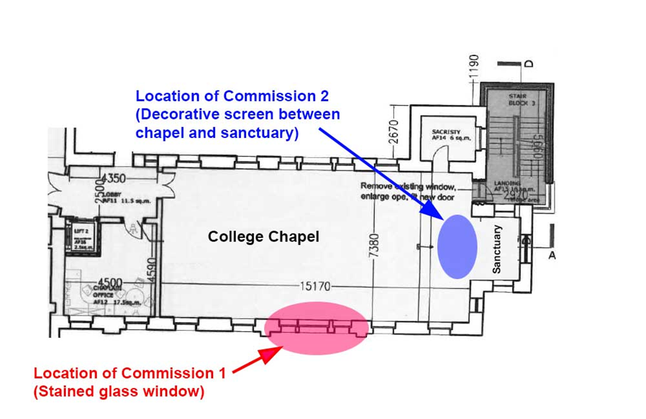

Fig. A1 Layout of College Chapel, showing location of Commission 1 and Commission 2

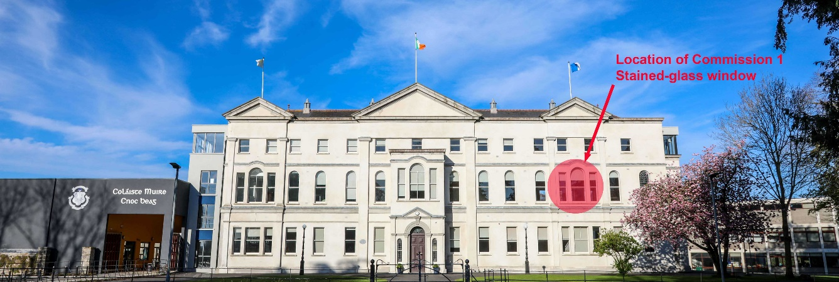

Fig. A2 External view of Knockbeg College, with first floor chapel windows (location of Commission 1) highlighted.

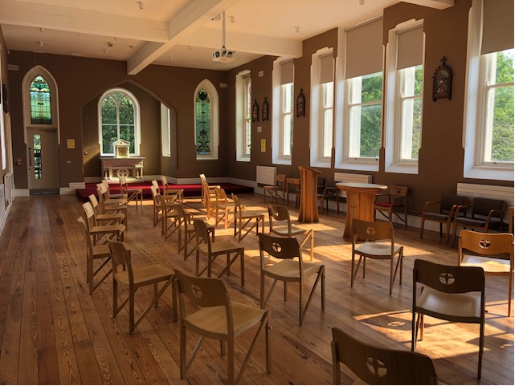
Fig. A3 Interior of College Chapel, looking south towards sanctuary and tabernacle (location of Commission 2). The window(s) behind the modern altar and lectern on the right is the location for Commission 1 (stained-glass installation)
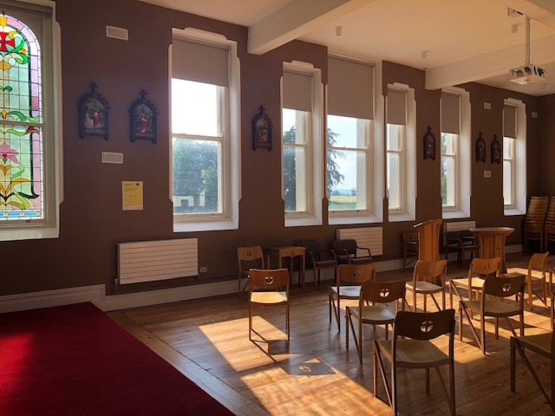
Fig. A4 Interior of College Chapel looking towards location for Commission 1.
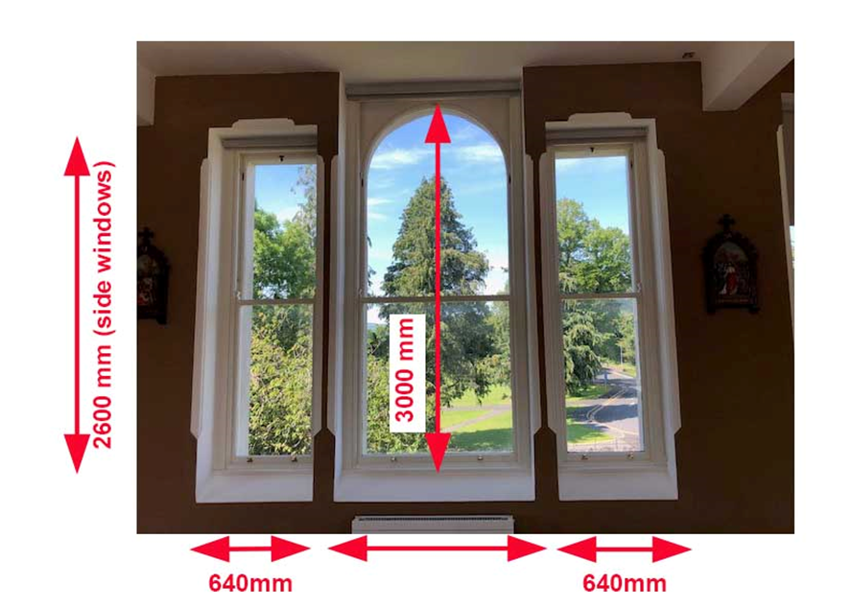
Fig. A5 Detailed photograph of location for Commission 1 (stained-glass installation). All dimensions are approximate and will be subject to checking on site during Stage 2.
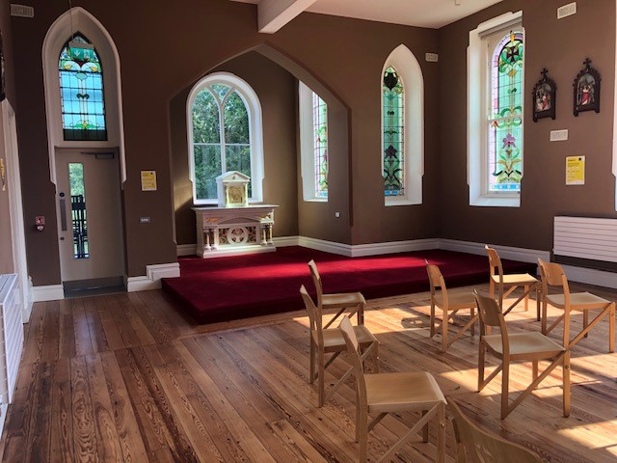
Fig. A6 Raised sanctuary platform with tabernacle at south end of chapel. Commission 2 involves the installation of a decorative screen to provide separation between the chapel and the sanctuary.
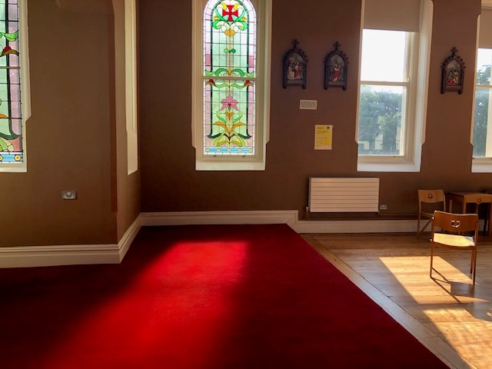
Fig. A7 Detail of raised platform of sanctuary. Commission 2 involves the installation of a decorative screen to provide separation between this raised area and the chapel.

APPENDIX B

STAGE 1 APPLICATION FORM FOR COMMISSION 1
(Stained-glass window on east wall of chapel at Knockbeg College)

Name of Artist: __________________________________________________

Contact Address: (please note all correspondence will be sent to this address)

___________________________________________________________________

___________________________________________________________________

Telephone/Mobile: ____________________ email: ________________________________

SECTION 1: APPROACH TO THE COMMISSION
Please give a short description of your art practice and your approach with reference to this commission (maximum 500 words):

Sketches or other images to illustrate your approach may be submitted as supporting documentation and should be clearly labelled.

SECTION 2: SUPPORTING DOCUMENTATION
Artists are asked to submit the following documentation. Where the submission is based on collaboration between more than one artist of craftsperson, separate documentation is required for each member of your team.

- Detailed Curriculum Vitae
- List of previous relevant projects or commissions. Please include details of the size, budget, timescale to completion, list of specialist or other contractors engaged by the artist in connection with the completion of these installations.
- Visuals of previous work in hard or soft copy.
- Names of referees and their contact details.
- Confirmation that if successful the artist is ready to submit a current Tax Clearance Certificate and provide relevant insurance documents. This confirmation is mandatory.
- If you have decided to collaborate with another artist or craftsperson, it is important to explain why and how the collaboration will work and how the responsibility for the delivery of the commission will be broken down. If applicable, please include images or previous collaborative works in this partnership. Note: It is not necessary for you to have previously collaborated with the other members of your team. New collaborations formulated to address the requirements of this commission are welcome.
- Sketches or other images to illustrate your approach to the commission.
- All documents should be clearly labelled, and a content list of items included in your submission should be provided.
- Please indicate if you require some or all of the submitted documents to be returned to you on completion of the assessment process. You are required to submit a stamped addressed envelope to facilitate the return of such material. The selection panel cannot return submitted material where no stamped addressed envelope has been supplied.

Note: Submissions by email should not exceed 10 megabytes. Digital files that are submitted by post should be stored on a USB stick only (not on CD or DVD).

Freedom of information:
Applicants completing this form should note that information provided to St. Mary’s College Knockbeg may be disclosed in response to a request made under the Freedom of Information Act (1997 and 2003).

Garda Vetting:
The successful artist will be subject to Garda vetting procedures.

SECTION 3: DECLARATION
I have read the award conditions, agree to be bound by them, and certify that the information in this application is correct to the best of my knowledge.

Signed ____________________________________

Date ________________________

This application form should be returned by email to principal@knockbegcollege.ie
or by post to the address below:

Per Cent for Art Commission
C/O The Principal
St. Mary's College Knockbeg,
Carlow, Co. Laois R93 RP78

Closing Date for receipt of completed application is 4pm, Friday 30th July 2021.

Please note that applications received after that closing date will not be accepted or considered.

APPENDIX C

STAGE 1 APPLICATION FORM FOR COMMISSION 2
(Decorative screen to sanctuary within chapel of Knockbeg College)

Name of Artist: __________________________________________________

Contact Address: (please note all correspondence will be sent to this address)

___________________________________________________________________

___________________________________________________________________

Telephone/Mobile: ____________________ email: ________________________________

SECTION 1: APPROACH TO THE COMMISSION
Please give a short description of your art practice and your approach with reference to this commission (maximum 500 words):

Sketches or other images to illustrate your approach may be submitted as supporting documentation and should be clearly labelled.

SECTION 2: SUPPORTING DOCUMENTATION
Artists are asked to submit the following documentation. Where the submission is based on collaboration between more than one artist of craftsperson, separate documentation is required for each member of your team.

- Detailed Curriculum Vitae
- List of previous relevant projects or commissions. Please include details of the size, budget, timescale to completion, list of specialist or other contractors engaged by the artist in connection with the completion of these installations.
- Visuals of previous work in hard or soft copy.
- Names of referees and their contact details.
- Confirmation that if successful the artist is ready to submit a current Tax Clearance Certificate and provide relevant insurance documents. This confirmation is mandatory.
- If you have decided to collaborate with another artist or craftsperson, it is important to explain why and how the collaboration will work and how the responsibility for the delivery of the commission will be broken down. If applicable, please include images or previous collaborative works in this partnership. Note: It is not necessary for you to have previously collaborated with the other members of your team. New collaborations formulated to address the requirements of this commission are welcome.
- Sketches or other images to illustrate your approach to the commission.
- All documents should be clearly labelled, and a content list of items included in your submission should be provided.
- Please indicate if you require some or all of the submitted documents to be returned to you on completion of the assessment process. You are required to submit a stamped addressed envelope to facilitate the return of such material. The selection panel cannot return submitted material where no stamped addressed envelope has been supplied.

Note: Submissions by email should not exceed 10 megabytes. Digital files that are submitted by post should be stored on a USB stick only (not on CD or DVD).

Freedom of information:
Applicants completing this form should note that information provided to St. Mary’s College Knockbeg may be disclosed in response to a request made under the Freedom of Information Act (1997 and 2003).

Garda Vetting:
The successful artist will be subject to Garda vetting procedures.

SECTION 3: DECLARATION
I have read the award conditions, agree to be bound by them, and certify that the information in this application is correct to the best of my knowledge.

Signed ____________________________________

Date ________________________

This application form should be returned by email to principal@knockbegcollege.ie
or by post to the address below:

Per Cent for Art Commission
c/o The Principal
St. Mary's College Knockbeg,
Carlow,
Co. Laois R93 RP78

Closing Date for receipt of completed application is 4pm, Friday 30th July 2021.

Please note that applications received after that closing date will not be accepted or considered.

