Updated Parent/Guardian and Student Guidelines during Remote Learning January 15th, 2020

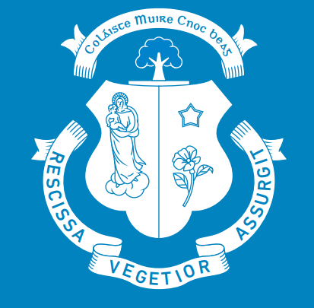
St Mary’s Knockbeg College

- Teams is the school approved remote learning platform that will be used.
- The best experience for online learning is to use a laptop, desktop or tablet. A phone may be used but this option may be more difficult for the student. Information on how to use an X-box/PlayStation to engage in remote learning has also been emailed to every student.
- Students should be in a quiet area of the house and free from distractions and are dressed appropriately for the online school day.
- Students should log on to Teams at least five minutes before the school day begins. If the teacher is presenting a live class, students will be notified in Teams through calendar. Students must wait until the teacher has started the meeting before joining.
- If a teacher is presenting a pre-recorded lesson, information and the lesson will be posted in the subject Teams site. Students should not hit meet now. The students should access the pre-recorded material for the timetabled class.
- When joining a live class, ideally, students will turn on their camera. Students may blur the background if they wish. No other background should be used.
- Students should enter an online class muted and use the hands up/chat function to address the teacher unless personally addressed by the teacher. Inappropriate use of the unmute function will not be tolerated. The student may be removed from the lesson.
- The chat function in Teams should only be used for class content and in all cases must be used appropriately.
- Students must never share the Teams meeting url for a live class. If a student has a difficulty in connecting to a class, they must contact the subject Teacher directly.
- At all times students are expected to abide by the school’s Code of Discipline and its Acceptable Use Policy. Escalating sanctions for disruptive behaviour will occur, from a verbal warning, to muting the student, to requesting a student’s camera be turned off with final removal of the student from the class. Incidents resulting in the above sanctions will be reported to the relevant year head.
- Any incidents of students using Teams to share or message inappropriate content as outlined on pg 20 of our Acceptable Use Policy, or of sharing a class meeting link with an outside organisation will face disciplinary action up to and including expulsion and referral to An Garda Síochána.
- A log of every student’s activity on Teams is stored on the central server and will be used as evidence if the school has to deal with behaviour deemed inappropriate and in contradiction of our Acceptable Use Policy and Code of Discipline.
- Students are not allowed to record/take pictures at any point in an online lesson. This is deemed to be a serious breech of the school’s Acceptable Use Policy.
- Parents/Guardians should contact the relevant year head, if a student has any issues regarding attendance or connection.
- Please do not expect all teachers to provide a one-hour full contact online class, as research has advised that screen breaks and time for independent learning and research are an essential element of any online school.
- Under Child Protections Guidelines, school staff cannot provide one to one tuition or support online, without agreed protocols including additional parental consent. Please be aware that school staff must adhere to all child protection guidelines while teaching online.
- Please communicate with teachers within school hours.
- All issues related to teaching and learning concerns online should be referred to the school principal on princpal@knockbegcollege.ie.
- Parents/Guardians need to ensure that their son(s) are fully aware of the updated remote learning guidelines and ensure they understand their responsibilities when engaging in remote learning.

