Easter 2020 Newsletter

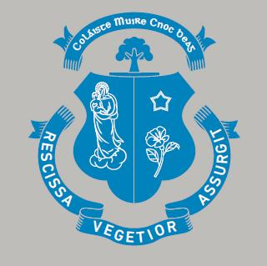

Covid 19 – Corona Virus
This will be a short Newsletter as there is really only one topic to discuss. Covid 19 has entered all our lives and disrupted every aspect of our daily routines to an extent that none of us could have fully understood a month ago. I want to advise all in our school community to follow the advice being provided by the HSE. While this is very tough to do, it is the best way to protect yourself and all of those that you care about. I want to remind everybody that while Ireland appears to have done very well so far in relation to the number of positive tests and fatalities associated with this deadly virus, we still have a long road to follow before we emerge at the other side and begin to return to normality.

In relation to school and school work, I want to commend the high numbers who wave been faithfully accessing and completing the work being provided by our dedicated teachers since we were advised to shut the school just over three weeks ago. It is great to see so many continue to take their educational development seriously during this time of great difficulty for us all. Thank you also to our parents, so many of whom completed the recent survey. It was wonderful to see how appreciative so many are of the efforts being made by our staff, while offering some useful advice at the same time. I would like to clarify one item in relation to the feedback for everybody which relates to the amount of time it took in certain instances to have work corrected and returned to students. Opening and correcting documents which have been uploaded for a teacher is a slow, onerous and time consuming task and requires a lot of patience from all. Please bear in mind that all teachers have worked very hard to adjust significantly the nature and format of providing work and assessing work for students in a very short period of time without having any format of training or support available to them.

We are now entering the formal break for our Easter holidays and most teachers will be taking a well-earned break to rest and recuperate after a very stressful time for us all. Some will have forwarded work for certain classes, especially those preparing for state examinations, to be undertaken across the break and will, as a matter of personal choice, be open to contact from students. For all our students who are preparing for the upcoming state examinations, please continue to do all that you can to keep up with your studies. I would ask you to pay heed to the message from Government yesterday that the Junior and Leaving Certificate examinations will take place for students this year. Closing date for submission of project work has been extended to May 15th. It is important that all exam students continue to communicate with your subject teachers to ensure that you are fully prepared to complete the work in a short period of time when we return to school.

We are at present scheduled to return to school on Monday April 20th. The current Lockdown is due to end a week earlier. It is possible that both will be adjusted by the government depending upon the medical advice provided to them in the coming days. If we cannot return to school, then all our teachers will resume the provision of work for classes from April 20th. In the meantime, please be careful and be safe. I have found these recent weeks stressful, as have many in our school community. We are however lucky to be living in an age where contact with friends and loved ones is very manageable through the use of our many devices such as mobile phones, personal computers etc., on platforms such as Instagram, Snapchat, WhatsApp and so many more. This at least eases the burden on so many at present which is of great importance to us all. If any of you have concerns that you feel we can help with across the next two weeks, please feel free to contact Mr. Hoyne or Guidance Counsellor bhoyne@knockbegcollege.ie or myself principal@knockbegcollege.ie and we will do all that we can to help or point you in the right direction.

Finally, I would like to wish you all a Safe, Peaceful and Happy Easter.

Michael Carew (Principal)

