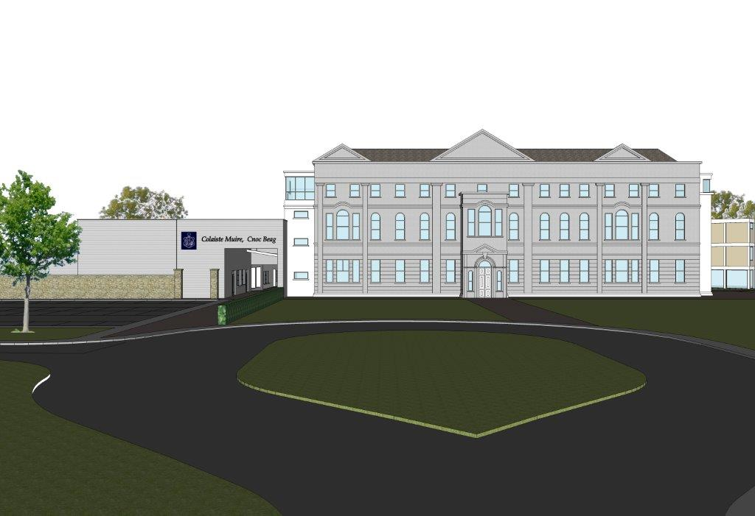

St. Mary’s Knockbeg College
Child Safeguarding Risk Assessment 2019

Note: This policy is effective from 01-03-2019 and replaced all previous Child Protection Policies

In accordance with section 11 of the Children First Act 2015 and with the requirement of Chapter 8 of the Child Protection Procedures for Primary and Post-Primary Schools 2017, the following is the Written Risk Assessment of St. Mary’s Knockbeg College Risk assessment as used in the Children First Act, 2015 means an assessment of any potential for harm to a child while availing of the provider’s service.

- List of school activities
- Daily arrival and dismissal of pupils
- Recreation breaks for pupils
- Classroom teaching
- One-to-one teaching
- One-to-one counselling
- Outdoor teaching activities
- Evening study programme
- Sporting Activities
- School outings
- School trips involving overnight stay
- School trips involving foreign travel
- Use of toilet/changing/shower areas in schools
- Annual Sports Day
- Evening events in school
- Parent Teacher Meetings
- Fundraising events involving pupils
- Use of off-site facilities for school activities
- School transport arrangements including use of bus escorts
- Care of children with special educational needs, including intimate care where needed
- Management of challenging behaviour amongst pupils, including appropriate use of restraint where required
- Administration of Medicine
- Administration of First Aid
- Curricular provision in respect of SPHE, RSE, Stay Safe
- Prevention and dealing with bullying amongst pupils
- Training of school personnel in child protection matters
- Use of external personnel to supplement curriculum
- Use of external personnel to support sports and other extra-curricular activities
- Use of external agencies for the provision of specific services on behalf of the school
- Care of pupils with specific vulnerabilities/ needs such as :-
- Pupils from ethnic minorities/migrants
- Members of the Traveller community
- bisexual or transgender (LGBT) children
- Pupils perceived to be LGBT
- Pupils of minority religious faiths
- Children in care
- Children on CPNS
- Recruitment of school personnel including :-
- Teachers/SNA’s
- Caretaker/Secretary/Cleaners
- Sports coaches
- External Tutors/Guest Speakers
- Volunteers/Parents in school activities
- Visitors/contractors present in school during school hours
- Visitors/contractors present during after school activities
- Site traffic through student populated areas during Construction Project
- Participation by pupils in religious ceremonies/religious instruction external to the school
- Use of Information and Communication Technology by pupils in school
- Application of sanctions under the school’s Code of Behaviour including detention of pupils, confiscation of phones etc.
- Students participating in work experience in the school
- Students from the school participating in work experience elsewhere
- Student teachers undertaking training placement in school
- Use of video/photography/other media to record school events
- After school use of school premises by other organisations
- Use of school premises by other organisation during school day
- Breakfast club
- Access to school grounds by unauthorised Persons during school opening hours

- The school has identified the following risk of harm in respect of its activities -
- Risk of harm not being recognised by school personnel
- Risk of harm not being reported properly and promptly by school personnel
- Risk of child being harmed in the school by a member of school personnel
- Risk of child being harmed in the school by another child
- Risk of child being harmed in the school by volunteer or visitor to the school
- Risk of child being harmed by a member of school personnel, a member of staff of another organisation or other person while child is participating in out of school activities e.g. school trip – academic, co-curricular or extra-curricular
- Risk of harm due to bullying of child
- Risk of harm due to inadequate supervision of children in school
- Risk of harm due to inadequate supervision of children while attending out of class/school activities
- Risk of harm due to inappropriate relationship/communications between child and another child or adult
- Risk of harm due to children inappropriately accessing/using computers, social media, phones and other devices while at school
- Risk of harm to children with SEN who have particular vulnerabilities
- Risk of harm to child while a child is receiving intimate care
- Risk of harm in one-to-one teaching, counselling, coaching situation
- Risk of harm caused by member of school personnel communicating with pupils in an appropriate manner via social media, texting, digital device or other manner
- Risk of harm caused by member of school personnel accessing/circulating inappropriate material via social media, texting, digital device or other manner
- Risk of self-harm on school based activities

- The school has the following procedures in place to address the risks of harm identified in this assessment -
- All school personnel are provided with a copy of the school’s Child Safeguarding Statement
- The Child Protection Procedures for Primary and Post-Primary Schools 2017 are made available to all school personnel
- School Personnel are required to adhere to the Child Protection Procedures for Primary and Post-Primary Schools 2017 and all registered teaching staff are required to adhere to the Children First Act 2015
- The school implements the SPHE curriculum
- The school implements the Wellbeing Programme at Junior Cycle
- The school has an Anti-Bullying Policy which fully adheres to the requirements of the Department’s Anti-Bullying Procedures for Primary and Post-Primary Schools
- The school has yard/playground supervision procedures to ensure appropriate supervision of children during, assembly, dismissal and breaks
- The school has in place clear procedures in respect of school outings
- The school has a Health and safety policy
- The school adheres to the requirements of the Garda vetting legislation and relevant DES circulars in relation to recruitment and Garda vetting
- The school adheres to the Teaching Council Code of Professional Conduct for Teachers
- The school complies with the agreed disciplinary procedures for teaching staff
- The school has a Special Educational Needs policy
- The school has in place procedures for the administration of medication to pupils
- The school –
    - Has provided each member of school staff with a copy of the school’s Child Safeguarding Statement
    - Ensures all new staff are provided with a copy of the school’s Child Safeguarding Statement
    - Encourages staff to avail of all relevant training
    - Encourages Board of Management members to avail of relevant training
    - Maintains records of all Staff and Board member training
- The school has in place procedures for the administration of First Aid
- The school has in place a code of behaviour for pupils
- The school has in place an ICT policy in respect of usage of ICT by pupils
- The school has in place a mobile phone policy in respect of usage of mobile phones by pupils
- The school has in place a Critical Incident Management Plan

- The school has in place procedures for the use of external persons to supplement delivery of the curriculum
- The school has in place procedures for the use of external sports coaches
- The school has in place clear procedures for one-to-one teaching activities
- The school has in place procedures for one-to-one counselling
- The school has in place procedures in respect of student teacher placements
- The school has in place procedures in respect of students undertaking work experience in the school
- The school has in place procedures in respect of pupils of the school undertaking work experience in external organisations

Important Note: It should be noted that risk in the context of this risk assessment is the risk of
“harm” as defined in the Children First Act 2015 and not general health and safety risk. The definition
of harm is set out in Chapter 4 of the Child Protection Procedures for Primary and Post- Primary
Schools 2017

In undertaking this risk assessment, the Board of Management has endeavoured to identify as far as possible the risks of harm that are relevant to this school and to ensure that adequate procedures are in place to manage all risks identified. While it is not possible to foresee and remove all risk of harm, the school has in place the procedures listed in this risk assessment to manage and reduce risk to the greatest possible extent.
This risk assessment has been completed by the Board of Management on ______________________ It shall be reviewed as part of the school’s annual review of its Child Safeguarding Statement.

Signed _____________________________________ Date ________________

Chairperson, Board of Management

Signed _____________________________________ Date ________________

Principal/Secretary to the Board of Management

